**Teaching-learning activities**

1. Realise the physical design of the COMPANY database.

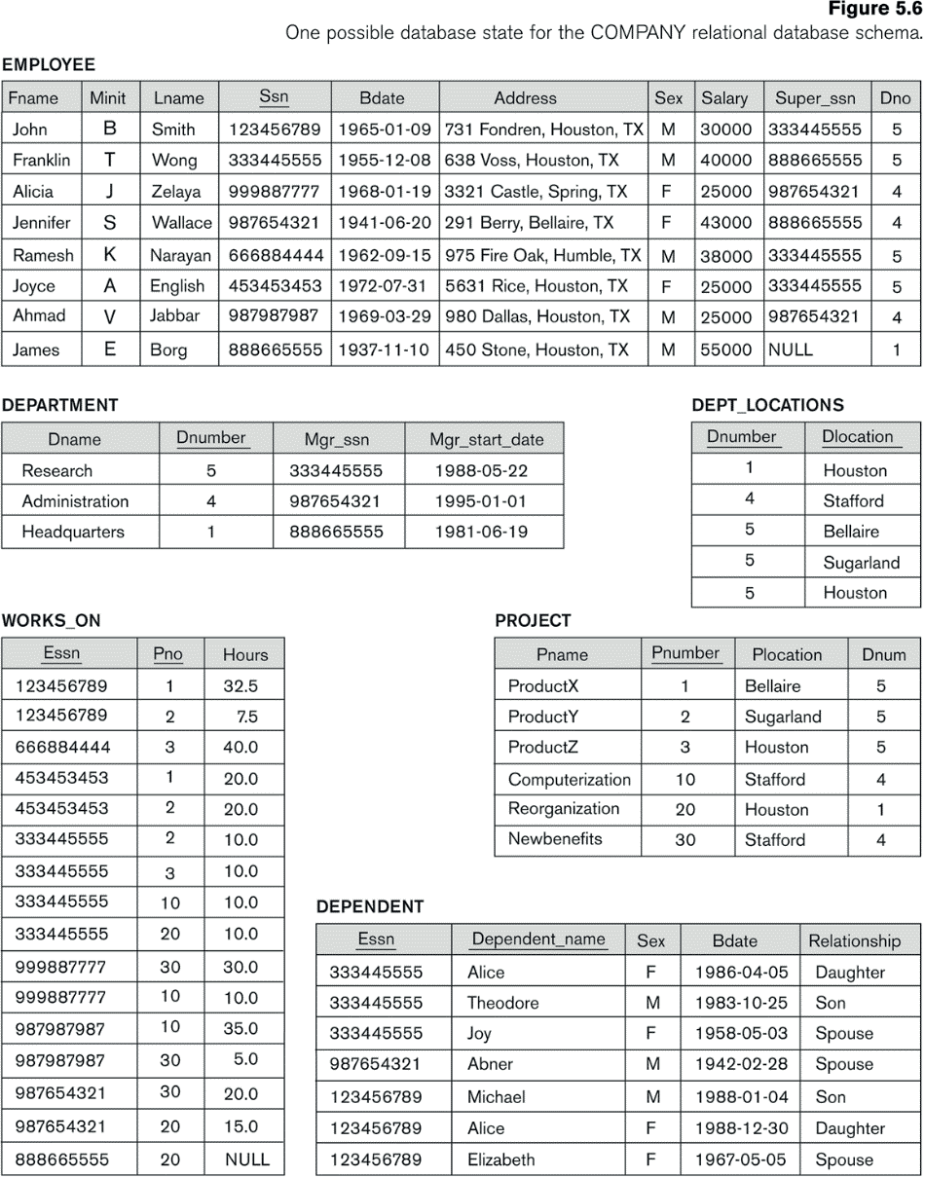

**Use the SQL language to carry out the exercise.**

1. The following modifications must be made in the ***Company*** database:

- Remove the Adress field from the Employee table.

- Add a column in the Project table called Hours that will indicate the duration in hours for each project.

- Removes the Mgr_start_date field from the Department table.

- Rename the Relationship column in the Dependent table to Family.

2. Carry out the physical design of the ***Startrek*** exercise worked on in previous units (without specialization)

- The tables should be created.

3. The following modifications should be made to the ***Startrek*** database created in the previous exercise.

- Add the City column to the PERSONAJE table.

- Add the column Birth_Date to the PERSONAJE table.

- Remove the column galaxia in the PLANETA table.

- Rename the columns “grado” to “categoría” in PERSONAJE table.